Problem 2 – Labyrinth Escape

You are given a rectangular field of size NxM, filled with numbers and directions. On each cell on the field there will be a direction marked with the letters l, r, u, d.
By given position (R, C) (Rth row and Cth column) the directions are as follows:
From (R, C) go l => (R, C-1)
From (R, C) go r => (R, C+1)
From (R, C) go u => (R-1, C)
From (R, C) go d => (R+1, C)

The numbers in the field are always as follows:

On the first row the values are from 1 to M, on the second row – from M+1 to 2*M, on the third row – from 2*M +1 to 3*M, on the Nth row – from (N-1)*M to N*M.

By given start position, find the path outside of the field, or print if you are lost.
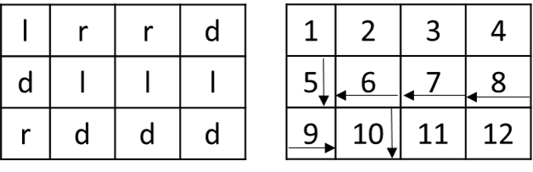
Example:
N = 3
M = 4
Start position: 1 3

Input
The method Solve accepts a zero-based array of strings. The arguments are as follows:
args[0] contains M and N separated by a single space (" ")
args[1] contains R and C – the start position (the star position is zero-based)
args[2] to args[N+2] contain exactly M characters(only the letters 'l', 'r', 'u' or 'd')

Output
The output data should be printed on the console.
The output should contain a single string – "out SUM_OF_NUMBERS_IN_THE_PATH" or "lost NUMBER_OF_CELL_IN_THE_PATH"
"out SUM_OF_NUMBERS_IN_THE_PATH" means the at some point you can go outside of the field
"lost NUMBER_OF_CELL_IN_THE_PATH" means that you are stepping on a cell that is already visited

Constraints
- N and M will be always between 1 and 500
- Allowed working time for your program: 0.2 seconds. Allowed memory: 16 MB.

Examples
Input example | Output example
args =[  "3 4",  "1 3",  "lrrd",  "dlll",  "rddd"] | out 45
args =[  "5 8",  "0 0",  "rrrrrrrd",  "rludulrd",  "durlddud",  "urrrldud",  "ulllllll"] | lost 21
args =[  "5 8",  "0 0",  "rrrrrrrd",  "rludulrd",  "lurlddud",  "urrrldud",  "ulllllll"] | out 442

Solution
function Solve(args) {
var nmStr = args[0].split(" ");
var n = parseInt(nmStr[0]);
var m = parseInt(nmStr[1]);
var posStr = args[1].split(" ");
var row = parseInt(posStr[0]);
var col = parseInt(posStr[1]);
var field = args.slice(2);
var sum = 0;
var count = 0;
var dirs = {
l: {
row: 0,
column: -1
},
r: {
row: 0,
column: 1
},
u: {
row: -1,
column: 0
},
d: {
row: 1,
column: 0
},
};
var dir;
var used = {};
while (0 <= row && row < n && 0 <= col && col < m) {
if (used[row * m + col]) {
return "lost " + count;
}
used[row * m + col] = true;
count++;
sum += row * m + col + 1;
dir = field[row][col];
row += dirs[dir].row;
col += dirs[dir].column;
}
return "out " + sum;
}

